**Social Media Pack: ECTMIH 2025**

**Call for collaboration:** promote the ECTMIH 2025 – Better health for all in a changing world:

We need your help in promoting the 14th European Congress on Tropical Medicine and International Health (ECTMIH), which will be held in Hamburg, Germany, from September 29 – October 2, 2025. This event, hosted by the Bernhard Nocht Institute for Tropical Medicine (BNITM) in collaboration with the Federation of European Societies for Tropical Medicine and International health (FESTMIH) and the German Society for Tropical Medicine, and Global Health (DTG), plays a vital role in advancing health policy and systems research.

## How you can help:

* Share our content: help spread the word by sharing our posts, tweets, and other social media content about ECTMIH 2025
* Create your own content: highlight the themes and key dates
* Use our hashtags: include #ECTMIH, #ECTMIH2025, #ECTMIH25, #BetterHealth #ForAll #ChangingWorld, #BetterHealthForAll, #ECTMIHAcademy in your posts to increase visibility
* Engage your network: invite your colleagues, friends, and followers to join the Congress. The more people involved, the greater the impact.

## Add this to your newsletter:

‘’The Bernhard Nocht Institute for Tropical Medicine (BNITM), the Federation of European Societies for Tropical Medicine and International Health (FESTMIH), and the German Society for Tropical Medicine, Travel Medicine and Global Health (DTG) are excited to announce the 14th European Congress on Tropical Medicine and International Health, (ECTMIH 2025) set to take place in Hamburg, Germany, from September 29th to October 2nd, 2025. In alignment with the European Union’s Global Health strategy, the Congress theme is "Better Health for All in a Changing World”. The main themes will be organised under the umbrella of One Health, and include the ongoing planetary health challenges at the intersect of human and animal health, within contexts of climate change and disrupted ecosystems, and the search for potential solutions. Sign up for their NL [here](https://ectmih-2025.de/general-information/newsletter-sign-up). Join us for this important event where researchers, decision-makers, and implementers from around the world will come together to share their insights and approaches for a more sustainable and equitable future in global health. You’ll find the LinkedIn event [here](https://www.linkedin.com/events/ectmih20257263140437509431296/)’’.

**Why it matters:**

The 14th European Congress on Tropical Medicine and International Health (ECTMIH) is an opportunity to exchange and network with researchers, decision-makers, and implementers from around the world. Your support is crucial in helping us reach a broader audience and ensuring a successful event.

**Key details to share:**

* Date: 29th of September to 2nd of October, 2025
* Location: Hamburg, Germany
* Email: [ectmih@bnitm.de](mailto:ectmih@bnitm.de)
* Website: ectmih-2025.de

**Tracks:**

* Track 1. Interfaces: Immunology and Interaction
* Track 2. Emerging Infections: Pandemics and Control
* Track 3. Tropical Medicine: Diseases and Care
* Track 4. One Health: Approaches and Solutions
* Track 5. International Health: Travel and Migration
* Track 6. Vulnerable Populations: Poverty and Neglect
* Track 7. Non-Communicable Diseases: Challenges and Society

**Cross Cutting Topics:**

* Climate and environmental changes
* Equality / Equity
* Behavioural Research and Implementation
* Digital Innovations

**Social handles and hash tags:**

* LinkedIn: [Bernhard Nocht Institute for Tropical Medicine](https://www.linkedin.com/company/bernhard-nocht-institute-for-tropical-medicine/posts), [Federation of European Societies for Tropical Medicine and International Health (FESTMIH),](https://www.linkedin.com/company/federation-of-european-societies-for-tropical-medicine-and-international-health) [German Society for Tropical Medicine, Travel Medicine and Global Health (DTG)](https://www.linkedin.com/company/tropmed-dtg)
* X: @BNITM_de
* Hash Tags: #ECTMIH2025, #ECTMIH, #ECTMIH25, #BetterHealthForAll, #BetterHealth #ForAll, #ECTMIHAcademy, #ECTMIHYouth, #HealthEquity2025, **#GlobalHealth2025**, #ECTMIHNetworking, #Innovate4Health

**Suggested posts for pre-promotion (Please choose the post with adequate length for your platform (X=250 signs, LinkedIN no sign limit):**

* Get ready for the 14th European Congress on Tropical Medicine and International Health in Hamburg, Germany, from September 29th to October 2nd 2025!." Don't miss out! #ECTMIH2025 #BetterHealthForAll #Innovate4Health ECTMIH 2025
* Calling all researchers, decision-makers, and implementers! The 14th European Congress on Tropical Medicine and International Health is happening in Hamburg, Germany. Let's pave the way for sustainable & equitable global health systems. See you there! #ECTMIH2025 ECTMIH 2025
* Save the date! The 14th European Congress on Tropical Medicine and International Health to Hamburg, Germany, from 29 September to 2 October, 2025. Join us to explore themes like planetary health, one health, and climate change. Be part of the conversation! #ECTMIH2025 #SustainableHealth
* Hamburg, here we come! The 14th European Congress on Tropical Medicine and International Health is the place to be from September 29 to October 2,2025. Exchange with experts, explore ground-breaking research, and contribute to a healthier future. See you there! #ECTMIH2025 ECTMIH 2025

**Call for Organised Sessions (online):**

* **Calling all global health leaders, researchers, and innovators!** The **European Congress on Tropical Medicine and International Health (ECTMIH 2025)** is just around the corner, and we’re thrilled to announce that **submissions for organized session proposals are NOW OPEN!** This is your chance to shape the program, spotlight critical topics, and lead impactful discussions that push boundaries in #GlobalHealth, #TropicalMedicine, and #PlanetaryHealth.
* **Do you have fresh perspectives or pioneering research to share?** Whether it's about #InfectiousDiseases, #OneHealth, #HealthEquity, or new health tech innovations, your session could be the one that inspires and drives change.
* 👉 Submit your session proposals by 15th December.

Join us in advancing health worldwide at #ECTMIH2025, where ideas become actions. Let’s make an impact together!

#ECTMIH2025 #HealthInnovation #GlobalCollaboration #PublicHealth

**Call for abstracts (online Dec/Jan):**

* 🚀 Ready to make your research count on a global stage?

The European Congress on Tropical Medicine and International Health (ECTMIH 2025) is now accepting abstract submissions! This is an great opportunity to present your findings, share insights, and connect with leaders across #GlobalHealth, #TropicalMedicine, and #InternationalHealth.

* 📅 Submit your abstract by [submission deadline date]! Your research deserves to be heard—share it with the global health community at #ECTMIH2025. Let’s push boundaries for #Better HealthForAll. Submit today! #ResearchImpact #GlobalHealthInnovation #HealthEquity #PublicHealthScience

**Registration will be online from End of January:**

* Don't miss out on #ECTMIH2025! Register now for exclusive global health insights and opportunities. Find out more and secure your spot today! Link here: <https://ectmih-2025.de/registration>
* Discover the latest global health advancements at #ECTMIH2025. Find out more and register now by visiting this link: <https://ectmih-2025.de/registration>
* Engage & exchange with global health experts at #ECTMIH2025. Learn more and secure your place by visiting this link: <https://ectmih-2025.de/registration>

**ECTMIH Academy:**

* Interested in strengthening your global health skills & competency? Register now for the #ECTMIHAcademy on 28 September 2025. Find out more and secure your spot today! Only 100 tickets available. Link [here: https://ectmih-2025.de/programme-abstracts/ectmih-academy](here:%20https://ectmih-2025.de/programme-abstracts/ectmih-academy)

**Graphic for social media on the next page–** click and save as a picture.

**Logo**

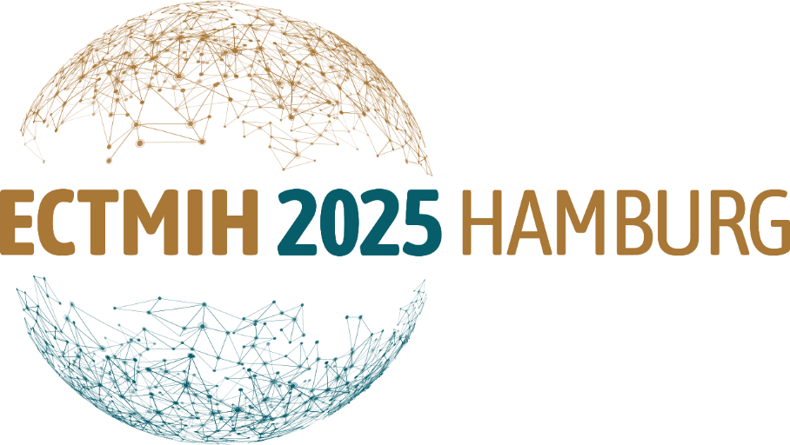

**LinkedIn Banner Format:**

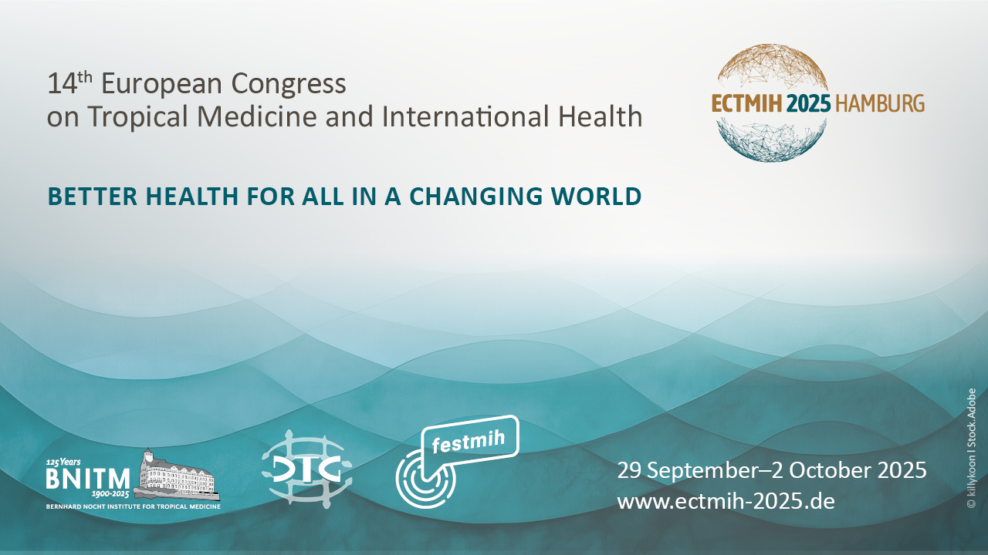

**Mobile Page Banner Format 1920 * 480px:**

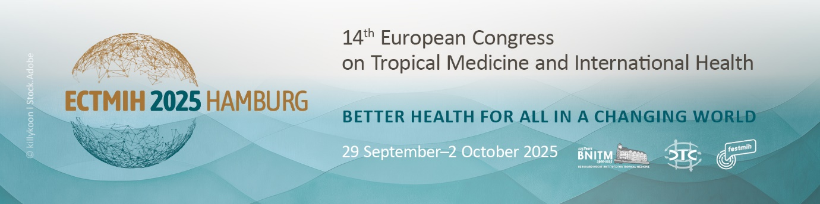

**Website Banner Format 3840 * 800px:**

